ARTICLE

PURPOSE:
The goal of an article is usually to talk about a topic you like or in which you are an expert. Also, your article should aim to keep the reader engaged and, in some cases, recommend whatever it is you are talking about

- ANSWER THE QUESTION
- PLAN your article.
- Give your article a title.
- Make sure you have at least 4 paragraphs.
- Ask rhetorical questions to get your readers’ attention. Eg. What would the world be like without oil? What will life be like in 20 years time?
- Speak directly to your readers. Eg. Let’s just imagine some of the possibilities.
- Give examples where appropriate.
- Use humour where appropriate
- Give a conclusion and summary in the last paragraph.
- Finally, give your opinion where appropriate.
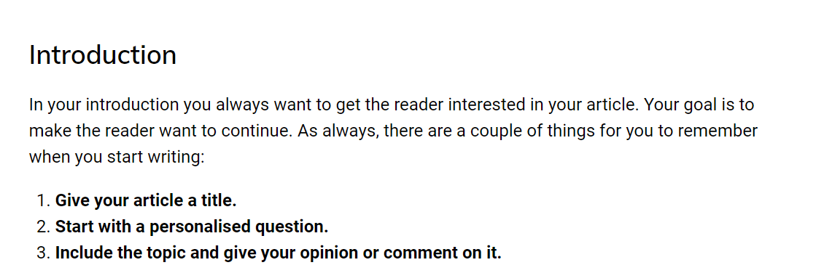
- REVISE your article to correct mistakes

LANGUAGE:
Articles are usually expected to be less formal than essays. Because they are intended to entertain, you can use more relaxed language, using contractions, phrasal verbs and more informal words. Also, it is common to use rhetorical questions and exclamation marks to keep the reader engaged or to make a point.

USEFUL LANGUAGE:
- I have the feeling that …
- My own feeling on the subject is that …
- I have no doubt that …
- I am sure / I am certain that …
- I think / consider / find / feel / believe / suppose / presume / assume / reckon that …
- I hold the opinion that …
- I dare say that …
- I guess that …
- I bet that ….
- I gather that …
- It goes without saying that …

Giving your own opinion
- In my opinion, …
- In my eyes, …
- To my mind, …
- As far as I am concerned, …
- Speaking personally, …
- From my point of view, …
- As for me / As to me, …
- My view / opinion / belief / impression / conviction is that …
- I hold the view that …
- I would say that …
- It seems to me that …
- I am of the opinion that …
- My impression is that …
- I am under the impression that …
- It is my impression that …
Developing your points
- Another advantage of …
- On top of all that…
- What is more, …
- Above all,,,
- The reason I think this is…
- The reason I feel this way is…
- On top of that, …
- Let’s start with …

Involving the reader
- Have you ever thought about…?
- How would you feel if …?
- What would you think of…?
- Are you one of those people who …?
- If the answer is …, you should….
- What do you reckon to …?
- What would life be like if…
- Just think for a moment…
- Just imagine…

Justifying opinions
To begin, you can use these basic (B1) phrases to justify an opinion in English:
- because…
- the reason is…
- the reason I believe that is…
- the facts suggest…
- the evidence shows…
- taking into account what I have seen…
When you ARE certain, try one of these (B2) phrases:
- There is a lot of evidence to support my point of view. For example…
- There are many facts in favour of my opinion. One such fact is…
- From my own personal experience, I am lead to believe…
When you are not completely certain, you can try one of these more advanced (C1) English phrases:
- I don’t have any special reason for believing this. It just seems right to me that…
- I could be wrong as I have no special reason for believing this. I just feel this is right as…
- I’m not sure why I feel this way but I have reason to believe…

